Advanced Computer Networking and Security - 5800

Assignment -4

ICMP Redirect

Name: SAI ROHIT JONNADA

ID :700723743

TURNING ON THE DOCKER

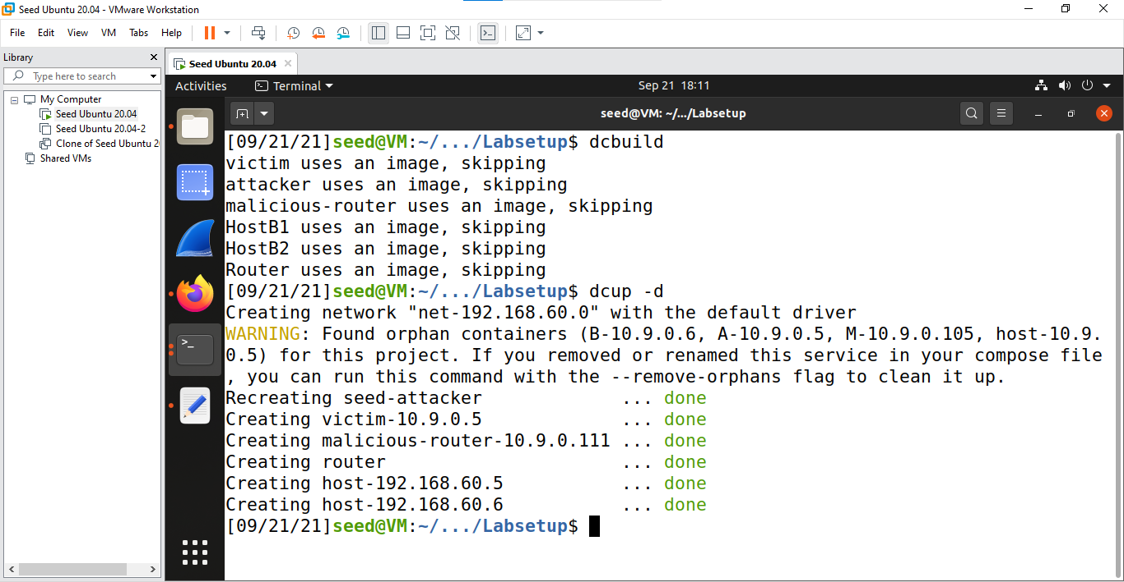

Checking the victim is connected to the attacker router (malicious router with address 10.9.0.11)

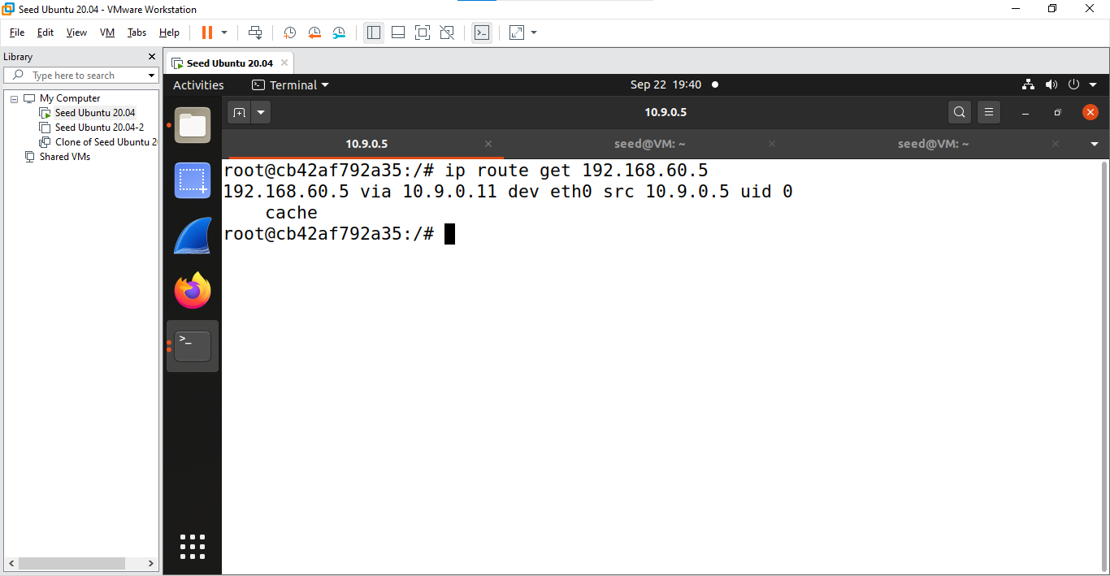

Ping 192.168.60.5 from victim ip 10.9.0.5

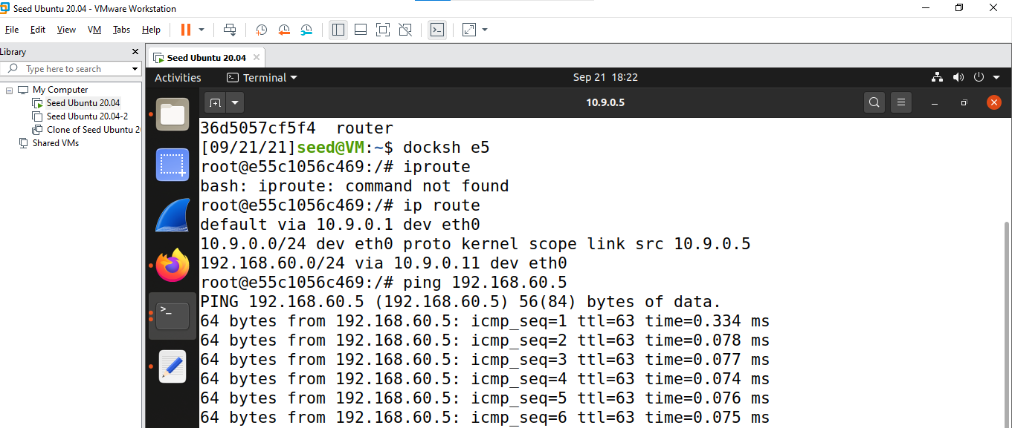

Code for icmp redirect

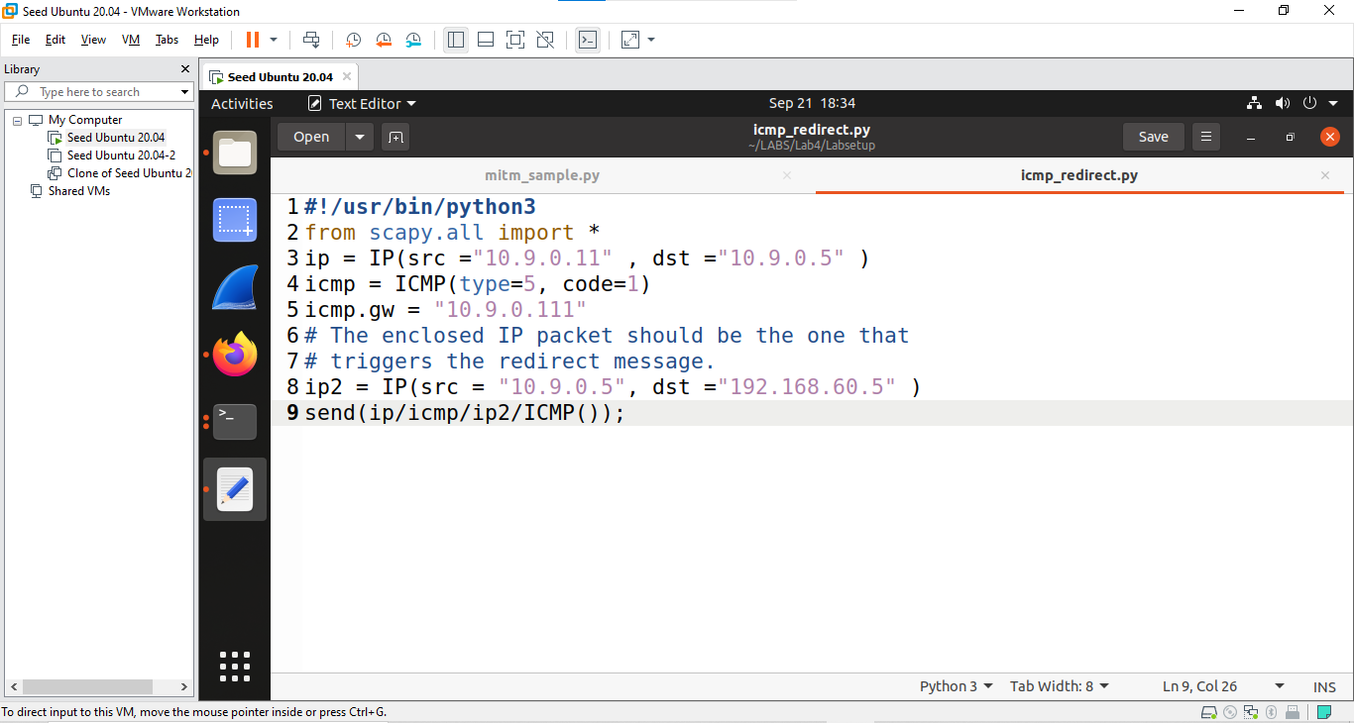

Running the icmp redirect code

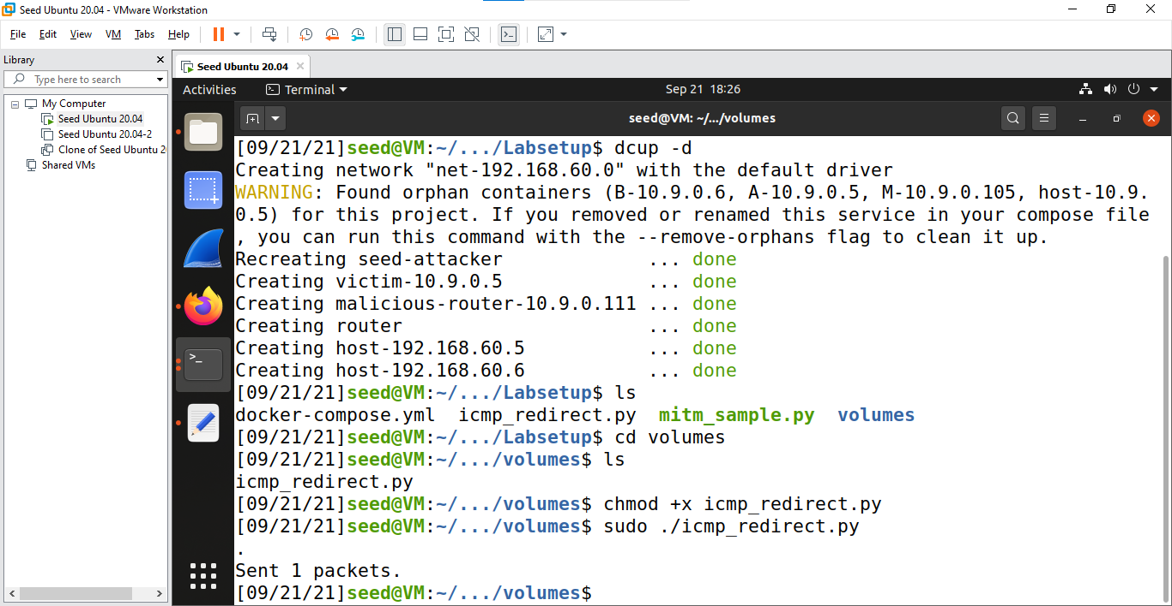

Successfully Poison the cache

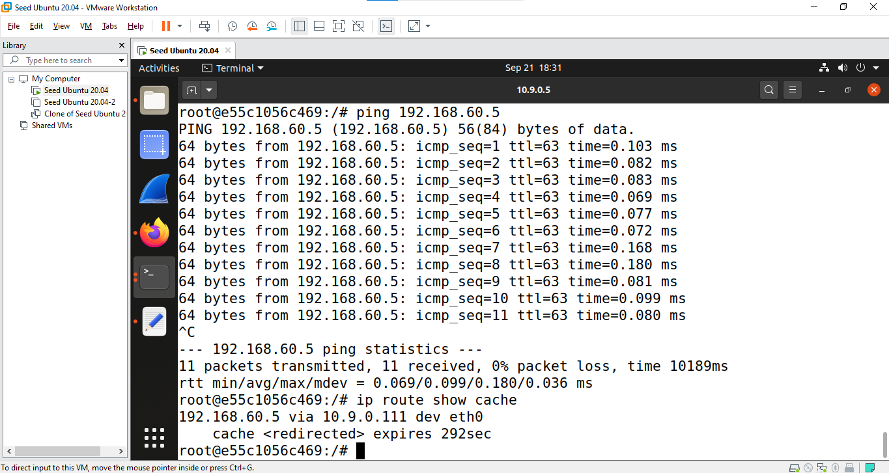

Trace route to check how the packets are going

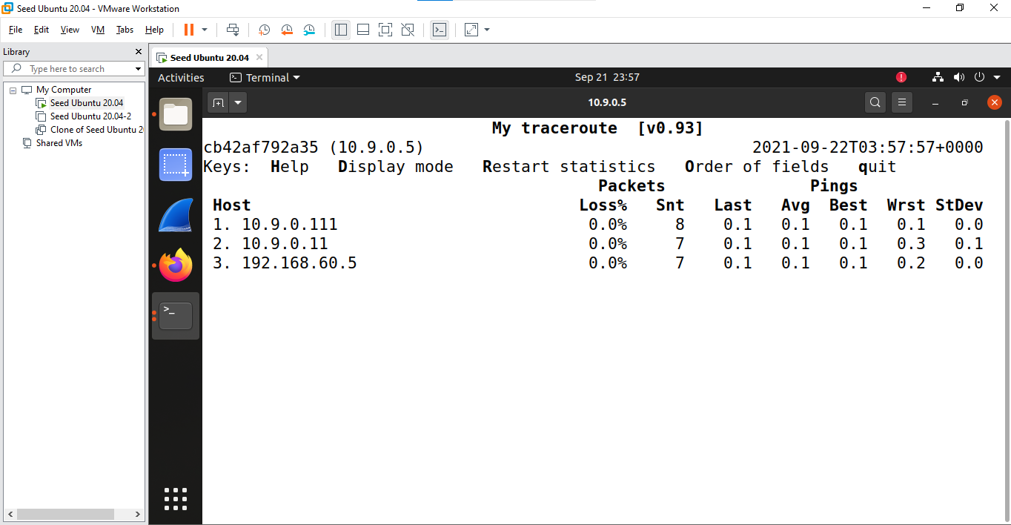

Creating the connection between victim and 192.168.60.5 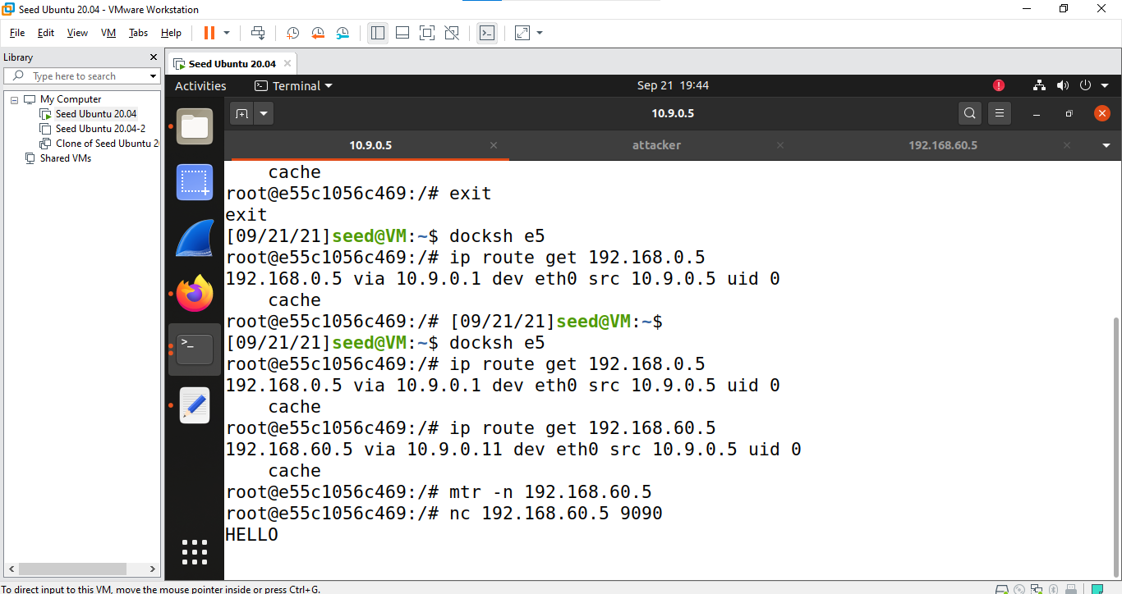

Receiving the messages from the victim

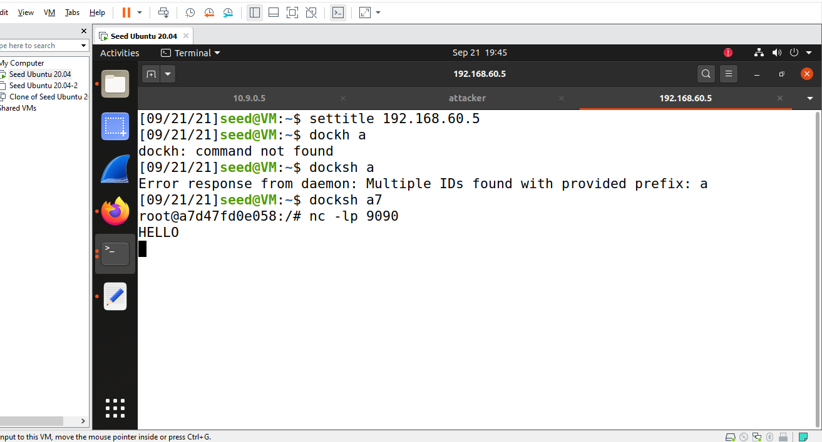

Disabling the ip forward to start MITM Attack

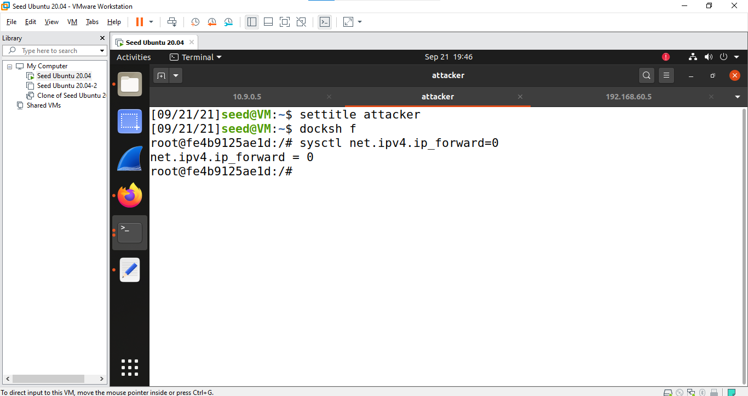

Running the MITM Sample code and got the packets tracked in the attacker

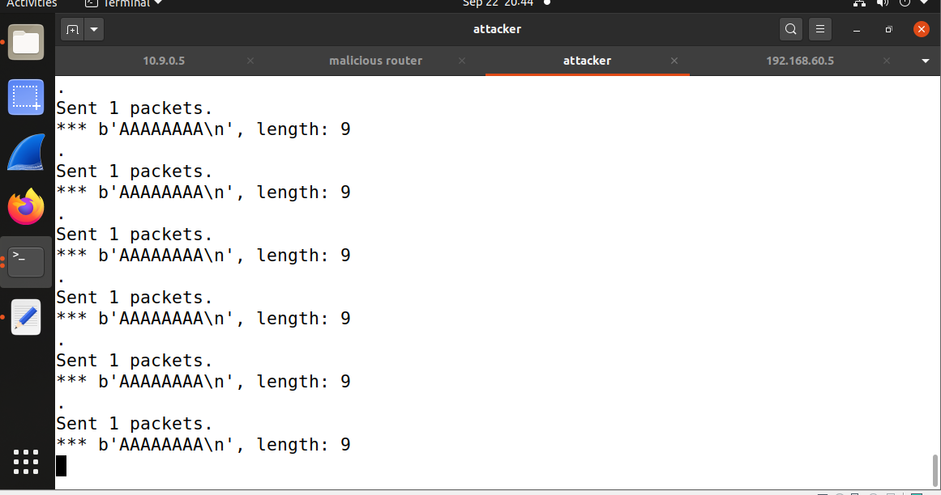

Successful spoofed the packets

